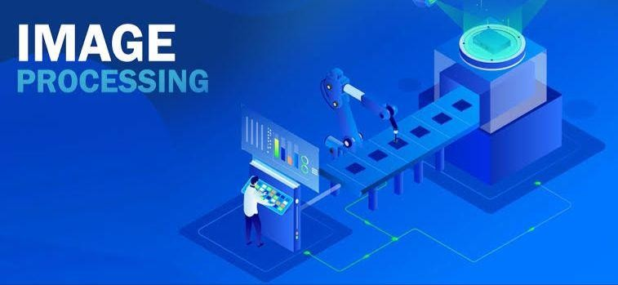

Image Processing for Video Frame Selection and Enhancement Report

CSE281||Digital Image Processing Under supervision of: **Prof. Gamal Fahmy**

|  |  |  |  |
| --- | --- | --- | --- |
| * **Team members:** | | | |
| **Student ID** | **Student Name** | **Project Evaluation** | |
| **222200006** | Mohamed Mahmoud Hamed | **Report** |  |
| **Presentation** |  |
| **Code** |  |
| **Total** |  |
| **222200021** | Islam Mohamed El Sayed | **Report** |  |
| **Presentation** |  |
| **Code** |  |
| **Total** |  |
| **223108628** | Shrouq Hesham Salman | **Report** |  |
| **Presentation** |  |
| **Code** |  |
| **Total** |  |
| **222101758** | Nada Abd El Karim Ahmed | **Report** |  |
| **Presentation** |  |
| **Code** |  |
| **Total** |  |
| **222200004** | Mohamed Rady Salah | **Report** |  |
| **Presentation** |  |
| **Code** |  |
| **Total** |  |
|  | | | |

# Introduction

– Image processing has become an essential tool in various fields, from medical imaging to multimedia applications. With advancements in computational power and software frameworks, it is now possible to manipulate and enhance images efficiently. This report presents a project that combines video processing and image enhancement techniques to enable users to interactively select, enhance, and save frames from a video. The project focuses on improving the visualization of frames, particularly X-ray images, through advanced processing techniques such as CLAHE, morphological segmentation, and colormap application.

* **PROPOSED SOLUTION**

This project proposes a user-friendly application for video frame selection and enhancement. The application is built using Python, leveraging libraries like OpenCV for image processing , Tkinter for GUI development, and Pillow for seamless integration between OpenCV and Tkinter. The tool provides a simple yet powerful interface for users to:

1. **Load Video Files:** Browse and open video files of various formats.
2. **Navigate Frames:** Use a slider to dynamically select any frame from the video.
3. **Apply Enhancements:** Choose from several processing options:
   * **Enhance (X-ray):** Utilize CLAHE (Contrast Limited Adaptive Histogram Equalization) to improve contrast and visibilCity, especially for grayscale images.
   * **Morphological Segmentation:** Reduce noise and isolate regions of interest using morphological operations like opening.
   * **Colorize:** Apply colormaps (e.g., JET) to visualize intensity distributions in a visually interpretable manner.
4. **Save Frames:** Compress and save the processed frames with adjustable quality.

The proposed solution bridges the gap between manual video analysis and automated image enhancement, allowing users to gain insights from visual data while maintaining full control over frame selection and processing.

# Results and Evaluation

The application successfully implements real-time video frame selection and processing with the following outcomes:

1. **Frame Navigation:** Users can interactively navigate through video frames using a slider, ensuring precise frame selection.

The application handles videos with varying resolutions and frame counts seamlessly.

## Enhancement Techniques:

**CLAHE:** Improved the visibility of X-ray images by enhancing local contrast without over-amplifying noise. This method is particularly effective for medical imaging applications.

**Morphological Segmentation :** Reduced background noise and highlighted regions of interest, making it easier to analyze specific features in an image.

**Colormap Application:** Added false colors to grayscale images, enabling better interpretation of intensity patterns for scientific and multimedia purposes.

1. **User Interface (UI):** Intuitive layout with clearly labeled buttons for loading videos, enhancing frames, segmenting images, and saving outputs. Real-time preview of the selected frame and its processed versions, providing instant feedback to users.
2. **Performance :** The application processes frames efficiently, with enhancement and segmentation operations completing within seconds for standard video resolutions.

Frame saving functionality allows users to store high-quality compressed images, balancing file size and visual fidelity.

* + **Output:**

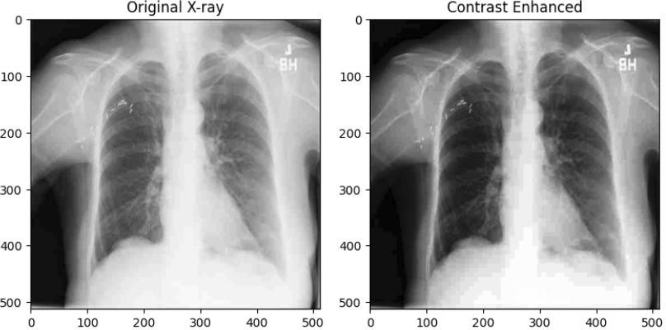

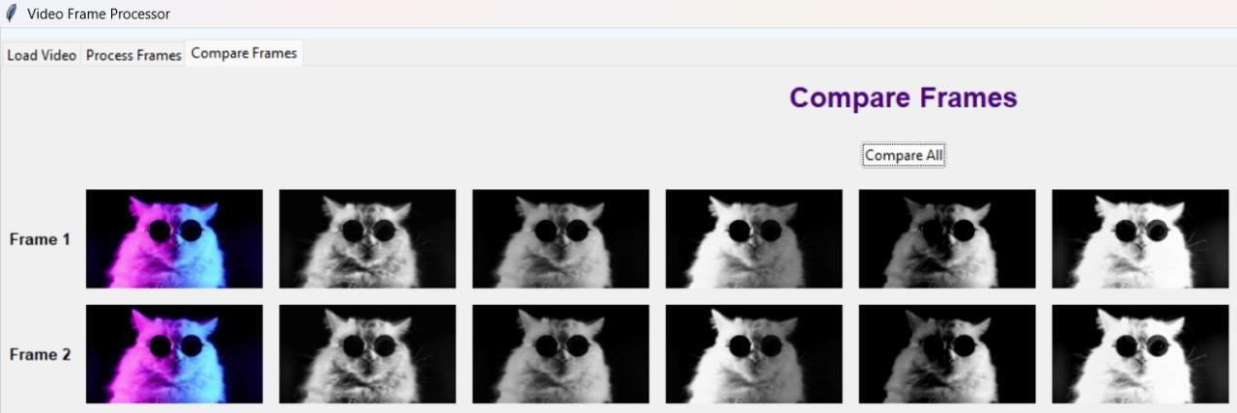

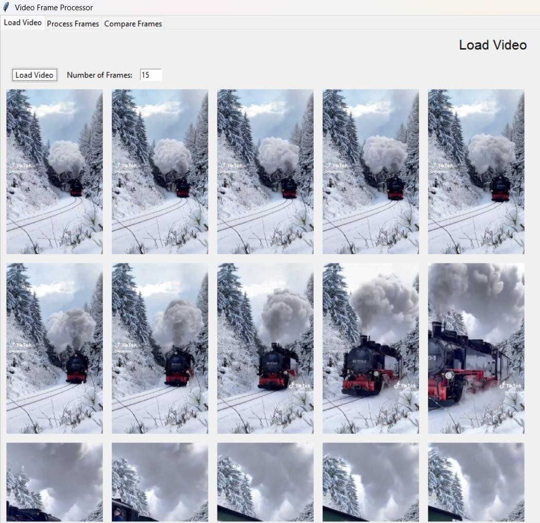

## Conclusion

The Video Frame Selector Application demonstrates the effectiveness of combining interactive GUI elements with advanced image processing techniques. By enabling users to select and process specific frames from a video, the application addresses the need for precise and flexible image analysis tools. Its robust design and versatile functionality make it a valuable asset for fields like medical imaging, multimedia analysis, and scientific research.This project highlights the potential of integrating Python libraries like OpenCV and Tkinter to create powerful yet accessible tools for image processing. Future developments could include adding features like automated frame extraction, batch processing, and support for additional

enhancement algorithms.